What are the main teachings of Confucius?

Confucius expounded a system of social and political philosophy which he conveyed to a group of disciples. His teachings and sayings were later collected by the disciples of Confucius in a book known in the West as the [Analects](http://www.confucius-1.com/analects/index.html). Confucius was also traditionally believed to have been the author or at least the editor of the classic Confucian texts called [the Five Classics](http://en.wikipedia.org/wiki/Five_Classics).

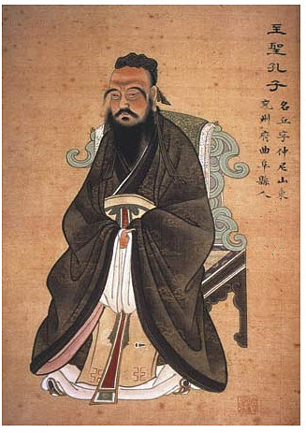

The Teachings of Confucius

[Confucius](http://en.wikipedia.org/wiki/Confucius) said that he was not an innovator and that all of his teachings were merely rediscoveries of what had been true in the past. Society was said to have deviated from an earlier Golden Age, and it was his task to guide it back to its proper condition. Appeals to ancient authority were probably customary at the time, and it is not true that Confucius was merely relating ideas which had existed before. In fact, there is reason to believe that much of what [Confucius taught](http://www.san.beck.org/CONFUCIUS4-What.html) was revolutionary at the time, as witnessed by the fact that after his death Chinese emperors attempted to suppress the spread of Confucianism by burning his books and executing Confucian scholars. However Confucianism and the teachings of Confucius eventually prevailed, and Confucianism eventually received Imperial sanction and came to be adopted as the state "religion" (the word religion is in quotes because there is debate whether Confucianism is actually a religion or is simply a system of philosophy.) The privileged position of Confucianism within Chinese society lasted for many centuries, until the Communist takeover, and had a profound influence on the development of China.

The teachings of Confucius are focused on two interrelated areas: Social Teachings, which deal with the proper behaviour of the individual in society and to his fellow men, and Political Teachings, which deal with the art of governance and the proper relationship of the Ruler to the ruled. He viewed education as central to achieving proper conduct both within Society and in Government.

**Social Teachings of Confucius**

Confucius taught that people should have compassion for one another, and to avoid treating others in ways that they themselves would not wish to be treated: “What you do not wish for yourself, do not do to others.” (Analects 12.2)

In order to be compassionate, people should avoid self-aggrandizement and be “simple in manner and slow of speech.” They should practice altruism and self restraint.

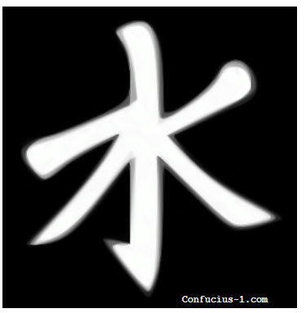

Confucian Symbol

Confucius taught that [the key to achieving proper self-mastery was adherence to correct ritual](http://plato.stanford.edu/entries/confucius/). In Counfucius' teachings, ritual encompassed both quasi religious practices as veneration of dead ancestors, as well as the broader concept of etiquette and correct social interaction. Confucius taught that there were mutual obligations arising between members of social relationships, for example as between Husband and Wife, Parents and Children, Older Brother and Younger Brother, and so on. Adherence to the proper conduct expected between members of these groupings would guarantee an harmonious relationship between them and also serve as the foundation of a just a stable society.

Although the subordinate members of a relationship (children to their parents, wives to their husbands) were required to be obedient, their obedience was not absolute and depended upon the superior member of the relationship (parent, husband for example) acting in accordance with his own obligations.

Confucius's teachings strongly emphasized the importance of following ritual. He said: "Look at nothing in defiance of ritual, listen to nothing in defiance of ritual, speak of nothing in defiance or ritual, never stir hand or foot in defiance of ritual." (Analects 12.1)

|  |
| --- |
| http://www.confucius-1.com/teachings/filialpiety.jpg |
| Filial Piety: In this Chinese print from 1848 a noted Song Dynasty calligrapher is protrayed as an example of filial piety because he loved his mother so much that he emptied her chamber pot himself. |

Within society, Confucius prescribed the following main ceremonies or rituals: Capping (a joyous occasion when a son achieved manhood on his twentieth birthday - analogous to a Bar Mitzvah), marriage, mourning rites, sacrifices, feasts, and interviews. These ceremonies were quite [complex and highly ritualized](http://www.csuchico.edu/%7Echeinz/syllabi/asst001/fall97/11kshinn.htm).

While to Westerners the emphasis on ritual may seem stultifying and oppressive, it must be remembered that the guiding principal in Confucius's social teachings is that people should follow the Five Virtues and love one another and treat each other with kindness, which is a concept shared by all great religions and humanistic philosophies.

**Political Teachings**

Much of Confucius's teachings focused on [the art of governance and how a ruler should act](http://socyberty.com/government/confucius-and-good-government/). Unlike [Machiavelli](http://www.historyguide.org/intellect/machiavelli.html), who expounded a concept of amoral statecraft in which he counseled the ruler on how to appear just in order to gain the trust of the people, while at the same time engaging in oppression and stratagems, Confucius advocated for true justice and compassion on the part of the ruler and the ruled. Only by being a just ruler would the ruler enjoy the Mandate of Heaven and continue to have the right to rule.

As with his social teachings, Confucius believed that the key to good governance lay in each man carrying out his duties as prescribed by his position within the hierarchy. He stated: “Good government consists in the ruler being a ruler, the minister being a minister, the father being a father, and the son being a son.” (Analects 12.11)

It was essential that the ruler possess virtue. Virtue would enable the ruler to retain the supreme position. “He who governs by means of his virtue is, to use an analogy, like the pole-star: it remains in its place while all the lesser stars do homage to it.” (Analects 2.1) Remarkably, given the violent nature of his times, Confucius believed that rulers should not have to resort to force or the threat of punishment to maintain power. He stated: "Your job is to govern, not to kill" (Analects XII:19)

As in the case of social relationships such as those between parents and children, husbands and wives, Confucius believed that the rulers should observe proper ritual in order to maintain their position and right to rule. These rituals included giving proper sacrifices to the ancestors at the ancestral temples, the exchange of gifts between members of the nobility which bound them together in a web of obligation and indebtedness, and acts of etiquette and decorum such as bowing.

**Confucius Teachings on Education**

|  |
| --- |
| Palace Examination at Kaifeng, Song Dynasty, China. |
| Palace Examination at Kaifeng, Song Dynasty, China. |

Confucius taught that one the key to self mastery was through scholarship and study. He stated "He who learns but does not think is lost. He who thinks but does not learn is in great danger." (Analects 2.15) In his own teachings, Confucius did not expound, but rather used asked questions of his pupils and used analogies to classic texts. According to Confucius “I only instruct the eager and enlighten the fervent. If I hold up one corner and a student cannot come back to me with the other three, I do not go on with the lesson.” (Analects 7.8).

In exhorting men to become gentlemen or Superior Men, Confucius recommended diligent study under a master familiar with the rules of correct behaviour. He recommended learning from the classics. In time, Confucius's emphasis on education and his belief that position and rank should be based on merit, led to the establishment of an imperial bureaucracy in which admission was based not on birth but on how well the applicant did on the imperial examinations. This was an admirable system which in theory at least rewarded merit and therefore recruited the best candidates; however in practice, the school curriculum, which was based on meeting the requirements of the [state examinations](http://www.sacu.org/examinations.html) became stultified. Too great an emphasis was placed on knowing and being able to quote classical authors while science and economics were neglected. Although this had not been Confucius's intent, the result was that China's education system produced a traditionalist bureaucracy which was ill equipped to deal with military and economic problems.

China was eventually conquered by neighboring barbarians, who established their own dynasties, though they maintained the educational and examination system. When the rapidly rising European powers came to China, China was slow to adopt Western technological innovations and as a result China suffered further humiliations as it was partitioned among spheres of influence by Germany, England and other European powers from the 1800s to World War 2.